Prtf1 Regex and OpenRefine
Author Name(s): Manuel Ø. Mørch

Task 1: List regex that extracts dates from http://bit.ly/regexexercise2 and formats them as YYYY-MM-DD?
URL for the solution: https://regex101.com/r/1Jsmnf/1
Brief explanation: The RegEx used collects day, month and year and puts them into three different groups, using parentheses. The periods (.) are left out of the parentheses, so they don’t end up in the wrong place later on,
The substitution takes the groups and places them in the YYY-MM-DD format and places new periods in the correct places.

Task 2 Regex to convert stopwordlist between R and Voyant format
R to Voyant:
https://regex101.com/r/1SLChr/1
Brief explanation:
The RegEx grabs everything unnecessary for an R-stopwordslist and it is then substituted with \n to create a new line instead. First and last citation mark will be removed manually as this is faster than trying to make a RegEx for it.
Voyant to R
https://regex101.com/r/odyAqg/1
Brief explanation:
RegEx grabs each time there is a new line, and then it is substituted with the correct formatting for R. (“, “). First and last citation mark will be added manually as this is faster than trying to make a RegEx for it.

Task 3 Does OpenRefine alter the raw data during sorting and filtering?
No, it does not alter the raw data during sorting and filtering, because having the raw data is better than having possible false data.

Task 4: What are the two most water-deprived months in Mozambique and Tanzania?
Column menu → Edit cells → Split multi‑valued cells…
- Separator: ;

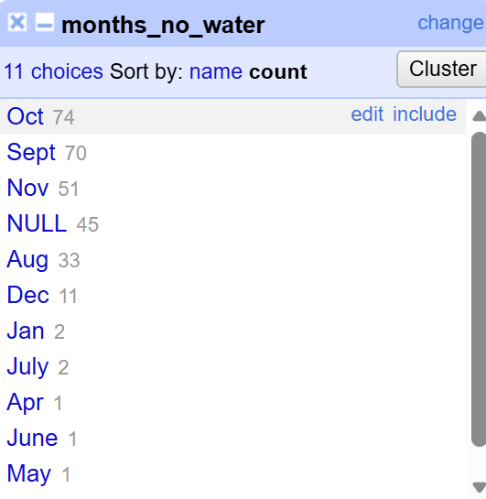
October and September were the two most water-deprived months in Mozambique and Tanzania

Task 5: Challenge - 10 most common occupations among ………………………….. in 1801 Aarhus
- Total number of people in your selected cohort:
2760 (mand)
- Define what is / is not an occupation:
I will define an occupation as what you do to earn your primary source of income. For example, “Husmand med jord og Smed” will be marked as “Smed”
I have only kept the primary jobs in the dataset i.e. deleting the job named second if several jobs were named. I have merged every occupation affiliated to the army as “soldat” to simplify the process a lot. I have also gotten rid of the hierarchies in occupations, so “bager” and “bagersvend” have been merged into “bager”.
- 10 most frequent occupations (list number of people practicing that job with each entry)
Top 10 occupations
Karl – 1040
Soldat – 479
Væver – 45
Skræder – 32
Tjener familien – 22
Snedker – 20
Matros – 19
Skriver – 16
Smed – 14
Vanfør - 14

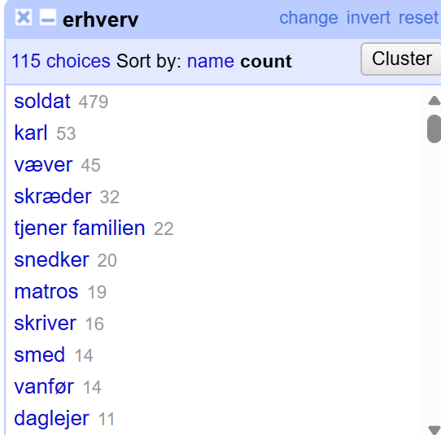
Figure 1 (before moving ”tjenestekarl”
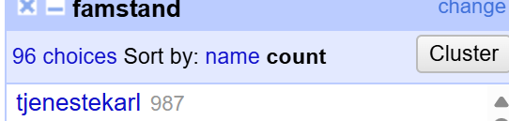
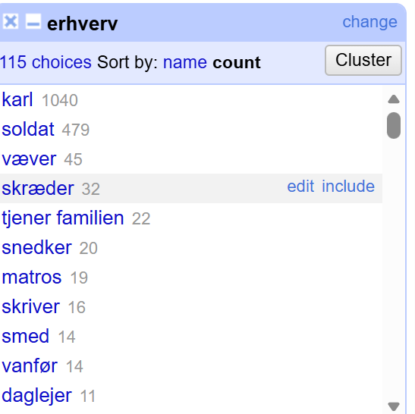
Figure 2 (After moving ”tjenestekarl” from “famstand“ to “erhverv”
The ”famstand” column had a lot of entries describing occupation, which I moved to the “erhverv” column by first filtering to only show the “tjenestekarl”, then using edit cells on “erhverv” column -> transform and then the following GREL expression:
cells["famstand"].value
This moved all “tjenestekarl” entries to the “erhverv” column.

